

SCHOOL OF AGRICULTURE AND ENGINEERING
Department of Mathematics and Computer Science

NAME: CALVIN
SURNAME: RONDOZAI
REG#: M223003
LEVEL: 4.1
MODULE: NATURAL LANGUAGE PROCESSING
CONTACT: +263782035594
EMAIL: m223003@elearning.gzu.ac.zw
ASSIGNMENT: Animal Health Chatbot (VetAssist)

Contents
1. Introduction 1
2. Technical Architecture 1
2.1 Technology Stack 1
2.2 System Architecture 1
3. Core Functionality 1
3.1 Data Processing 2
3.2 NLP-Based Disease Matching 2
3.3 Conversational State Management 2
4. Interaction Patterns 2
4.1 Multi-Modal Query Methods 2
5. Performance Optimization Techniques 3
5.1 Caching Mechanisms 3
5.2 Efficient Text Processing 3
5.3 Pre-computed Lookup Tables 3
6. How to run the Bot 4
Conclusion 4

Animal Disease Helper Chatbot

1. Introduction
VetAssist is a digital assistant designed to help animal caregivers access veterinary knowledge in a simple, convenient way. With an intuitive chat interface, users can ask about specific animal diseases or describe symptoms they're observing, and receive diagnostic suggestions and relevant educational information. It aims to bridge the gap between animal caregivers and veterinary expertise, providing accessible insights that assist in making better-informed decisions about animal health.

2. Technical Architecture

2.1 Technology Stack
The application utilizes the following technologies:
- Streamlit: Frontend web framework providing interactive UI components
- Pandas: Data manipulation and analysis
- spaCy: Natural language processing for text understanding
- scikit-learn: Machine learning algorithms for similarity matching
- NumPy: Numerical computing for vector operations
- Regular Expressions: Pattern matching for symptom extraction

2.2 System Architecture
The system architecture is structured into four key layers. The Data Management Layer is responsible for loading, organizing, and preprocessing disease-related information to ensure efficient retrieval and analysis. The Natural Language Processing (NLP) Layer processes user inputs, extracting relevant medical terms and symptoms to accurately interpret user concerns. The Recommendation Engine then matches these extracted symptoms to potential diseases by utilizing vector similarity techniques, providing personalized and accurate suggestions. Finally, the User Interface Layer offers a seamless conversational experience through an intuitive interface with styled chat elements, enhancing user engagement and accessibility.

3. Core Functionality

3.1 Data Processing
The system loads disease data from a CSV file containing structured information about animal diseases with the attributes; Disease names, associated symptoms, treatment methods, and preventive measures and advice. This data undergoes preprocessing through several optimization techniques The system implements caching mechanisms (@st.cache_data and @st.cache_resource) to optimize performance by preventing redundant computations during user interactions.

3.2 NLP-Based Disease Matching
A key feature of the application is its ability to match user-described symptoms with potential diseases through two complementary approaches:
- Vector Similarity Matching: User inputs are converted to vector representations using spaCy's word embeddings and compared against disease symptom vectors using cosine similarity.
- Keyword-Based Matching: The system extracts specific symptom keywords from user inputs and matches them against a precomputed symptom-to-disease mapping.
This dual approach improves recall by capturing semantic relationships between symptoms while maintaining precision through direct keyword matching.

3.3 Conversational State Management
The application implements a good state management system to maintain context across multiple conversation turns.
This enables the system to:
- Remember the current disease being discussed
- Track conversation flow across multiple exchanges
- Maintain context when navigating between different information categories
- Store potential disease matches for follow-up selection

4. Interaction Patterns

4.1 Multi-Modal Query Methods
The application supports multiple query approaches:
- Direct Disease Queries: Users can directly inquire about a specific disease
- Symptom-Based Queries: Users can describe observed symptoms for matching
- Categorical Information Requests: Users can request specific aspects of a disease (symptoms, treatment, prevention)
- Command-Based Interactions: Users can issue commands like "help" or "list"
The system implements a multi-turn conversation design pattern that allows for follow-up questions and progressive information disclosure. It also supports Selection-Based Interaction when multiple disease matches are found, the system presents them as selectable options:
This allows users to either:
- Select a disease by its number in the list
- Select a disease by typing its name
- Implicitly select a disease through context

5. Performance Optimization Techniques

5.1 Caching Mechanisms
The application incorporates strategic caching mechanisms to significantly enhance performance and responsiveness. Model caching ensures that the spaCy NLP model is loaded once and reused across sessions, minimizing loading times. Data caching is employed to store preprocessed disease information, thereby avoiding redundant computations and accelerating data retrieval. Additionally, vector caching is implemented by precomputing and storing symptom vectors, enabling quick and efficient matching during symptom-disease comparisons.

5.2 Efficient Text Processing
Text processing efficiency is achieved through:
- Lemmatization to normalize word forms
- Stop word removal to reduce noise
- Regular expression-based tokenization for symptom extraction
- TF-IDF vectorization for text comparison
- Tokenization to improves model performance

5.3 Pre-computed Lookup Tables
The system uses pre-computed lookup tables to speed up certain operations:
- Symptom-to-disease mapping for direct keyword lookup
- Disease dictionaries for rapid information retrieval
- Cached vectorization for quick similarity computation

6. How the Chatbot Works
Open command prompt and navigate to the folder with the bot. To run the local server type in “Streamlit run app.py” and it will auto redirect you to the web interface where you can interact with the chatbot. Make sure you installed all the required libraries in the requirements.txt file attached.
This animal health chatbot, developed using Streamlit, offers interactive support by helping users identify and learn about animal diseases. It uses a conversational interface where users can ask about symptoms, treatments, or specific diseases. The chatbot maintains context through st.session_state, storing chat history, selected diseases, and potential matches to ensure smooth, multi-turn interactions. When a user describes symptoms, the chatbot calls a matching function to identify possible diseases and presents them with confidence scores. Users can then select a disease by number or name, triggering a detailed overview. From there, they can ask for specific details like symptoms, treatment, or prevention advice. If a disease is mentioned directly in the input, the chatbot skips matching and provides immediate information. For general or unclear queries, it responds with guidance or asks for more details. It also supports quick replies for greetings and commands like "help" or "list diseases." The chatbot’s responses are formatted in HTML to enhance readability and engagement. It uses separate functions to handle disease selection, manage ongoing conversations, and respond appropriately based on user input. A send_message() function processes new inputs, updates the message log, and refreshes the interface.
Overall, this chatbot serves as a user-friendly digital assistant for veterinary queries, particularly helpful in areas where quick access to veterinary professionals is limited.
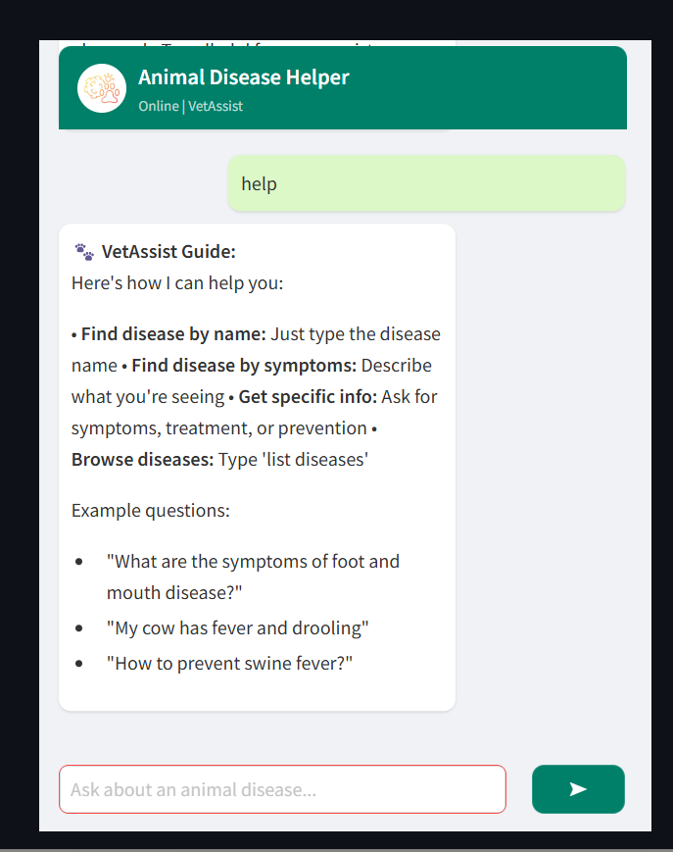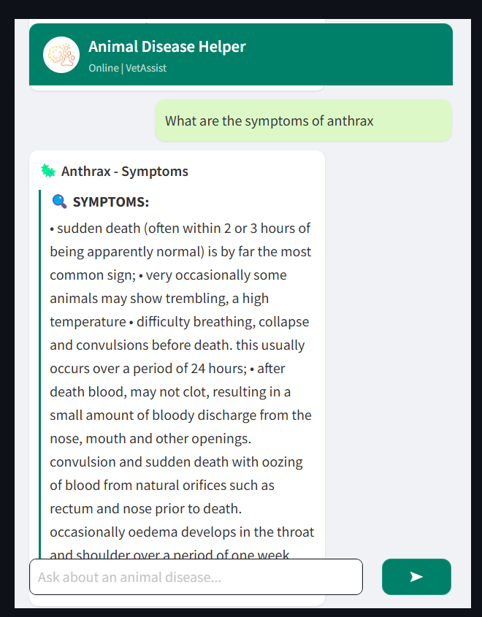
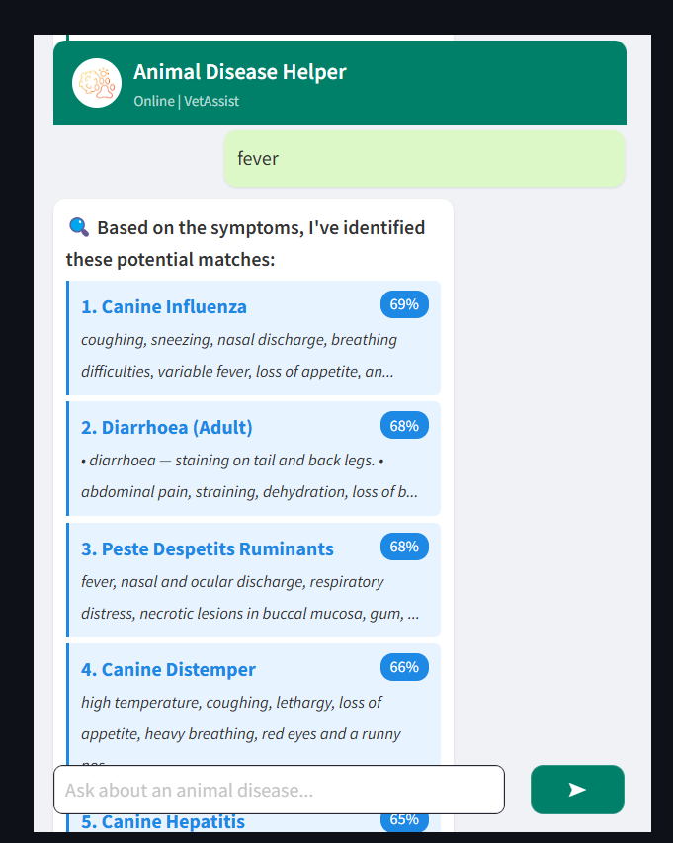
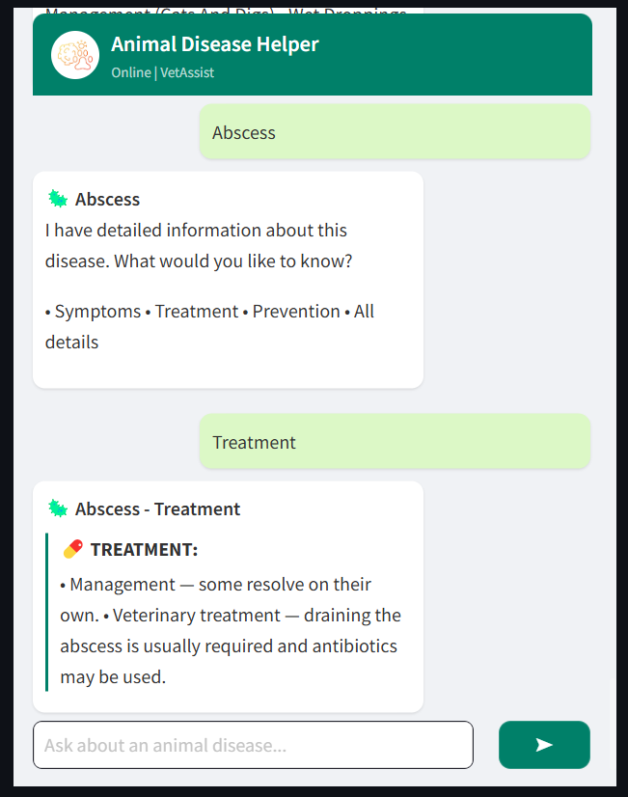

Conclusion
The Animal Disease Helper bot is a sophisticated application of natural language processing and information retrieval methods in veterinary medicine. Its interactive UI, symptom-matching ability, and context-aware interactions demonstrate sound implementation of technical as well as design principles.
The architecture of the system optimizes performance against user experience, providing an open, usable system for animal health information. The foundation established provides a solid platform for future enhancements and extensions.

